<div class="alert alert-success"><?=Yii::$app->session->getFlash('success')?> </div>

<?php else: ?>

<?php $form = ActiveForm::begin()?>

<div class="control-group">

<div class="controls">

<?= $form->field($model, 'email')->textInput(['class' => 'form-

control ']); ?>

<?php echo Html::error($model, 'email', ['class' => 'help-block'])?

>

</div>

</div>

<?php if (Captcha::checkRequirements() && Yii::$app->user->isGuest): ?>

<div class="control-group">

<?= $form->field($model, 'verifyCode')- >widget(\yii\captcha\Captcha::classname(), [

'captchaAction' => 'email/captcha'

]) ?>

</div>

<?php endif; ?>

<div class="control-group">

<label class="control-label" for=""></label>

<div class="controls">

<?=Html::submitButton('Submit', ['class' => 'btn btn-success'])?> </div>

</div>

<?php ActiveForm::end()?>

<?php endif;?>

5. Now, we have an e-mail submission form, as shown in the following screenshot, which validates the e-mail field. Let’s add Captcha:

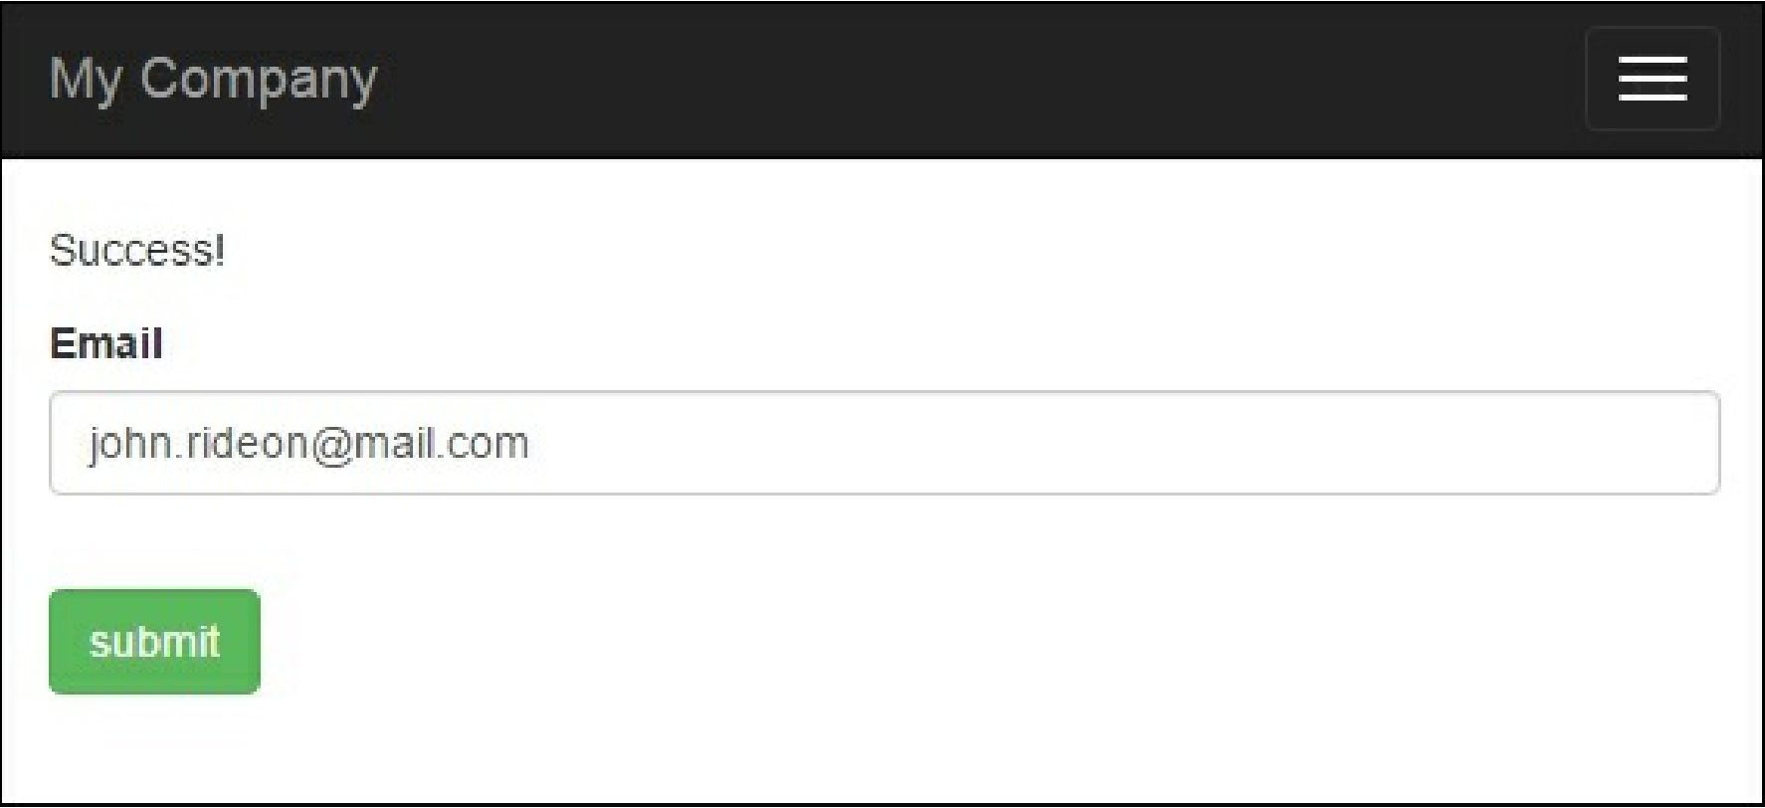

How to do it...

1. First, we need to customize the form model. We need to add $verifyCode, which will hold the verification code entered and add a validation rule for it: